Subject Code & Subject Title: BTSE 2003 Software Engineering

Subject Lecturer: Dr. Pang Yee Yong

Project Topic: Student Admission System

|  |  |  |
| --- | --- | --- |
| Student Name | Student ID | Batch |
| Lim Zi Cheng | B200041A | BoSE20-A2 |
| Khoo Zhi Hao | B200045A | BoSE20-A2 |

Contents

Introduction 1

Main Functionalities 2

Upload image 2

Crop image 2

Rotate image 2

Apply filters 2

Add special effects 3

Add watermark 4

Reset image 4

Download edited image 4

User Manual 5

Step 1: Upload an image 5

Step 2: Crop the image 8

Step 3: Rotate the image 10

Step 4: Apply filters 12

Step 5: Add special effects 14

Step 6: Add a watermark 16

Step 7: Download the image 18

Extra Step: Reset to the original image 21

Out of Scope 23

Programming Languages Used 23

# Introduction

The main objective of doing this project is to create a photoshop-like app. The programming languages that we used in this project are mostly web programming languages such as HTML, CSS, Java Script, jQuery, PHP and others.

Beside the programming languages stated above, we also used some image processing libraries such as “Croppie.js” and “Caman.js” in our application.

# Main Functionalities

## Upload image

Users can upload images in the format of “png”, “jpg” or “jpeg” from their local computers to the server for editing. The other types of images are not allowed to be uploaded.

## Crop image

Users can crop the image uploaded into their desired size by adjusting the shape of the cropping area provided.

## Rotate image

Users can rotate the image uploaded in our application. Every click on the “Rotate” button will rotate the image by 90o in a clockwise direction.

## Apply filters

If users are good at image processing, they can apply filters such as brightness, contrast, noise and others on the image uploaded by themselves. The list below is a list of filter functions provided.

**Filter Functions:**

1. Brightness
2. Contrast
3. Saturation
4. Vibrance
5. Hue
6. Exposure
7. Gamma
8. Sepia
9. Clip
10. Noise
11. Sharpen
12. Blur

## Add special effects

If users are not familiar with applying filters on images, they can simply add special effects provided by our application on the image uploaded. The list below is a list of special effects provided.

**Special Effects:**

1. Vintage
2. Lomo
3. Clarity
4. Sin City
5. Cross Process
6. Pinhole
7. Nostalgia
8. Her Majesty
9. Orange Peel
10. Love
11. Sunrise
12. Concentrate

## Add watermark

If users want to further protect the images edited from being misused by others, they can add a watermark on the image by using our application. In order to add a watermark on an image, users just need to enter some words as the watermark content and click on “Add Watermark” button. After that, our application will add a watermark with a white text and dark background at the top middle part of the image

## Reset image

If users do not satisfied with the image edited, they can reset the edited image to the original image by just clicking on “Reset Image” button located at the right bottom of the page.

## Download edited image

After users have edited the image uploaded and they want to save a copy of it in their local computers, they can click on the “Download Image” button at the left bottom of the page. Then, the image edited will be downloaded in “png” format to their local computers. The name of the image downloaded will be the combination of the original name of the image and the word “-edited” added after the original name. For example, if the original name of the image is “wolf.png”, the name of the downloaded image will be automatically set to “wolf-edited.png”.

# User Manual

## Step 1: Upload an image

*The first step is uploading an image from local computers by clicking on the “Browse” button.

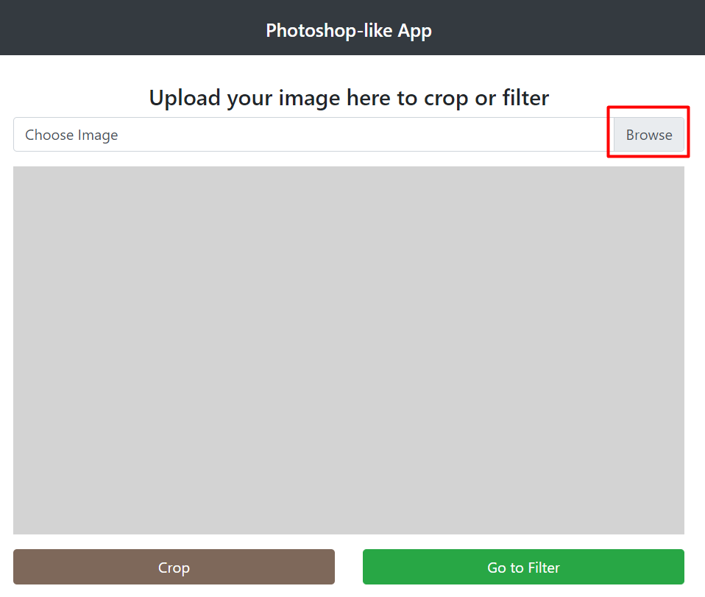

*Then, select an image for editing.

*In the example below, an image name “wolf.png” was chosen.

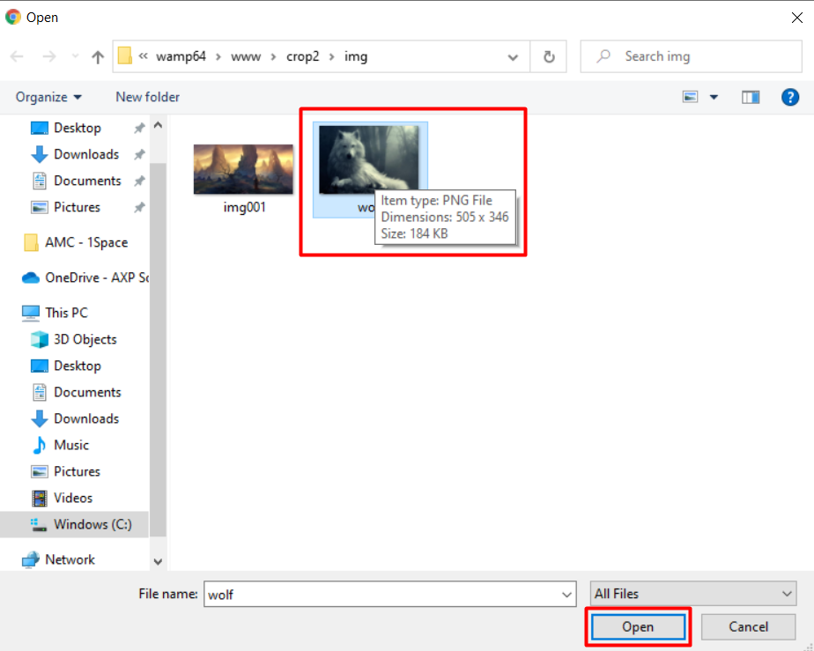

**The diagram below shows the image uploaded:**

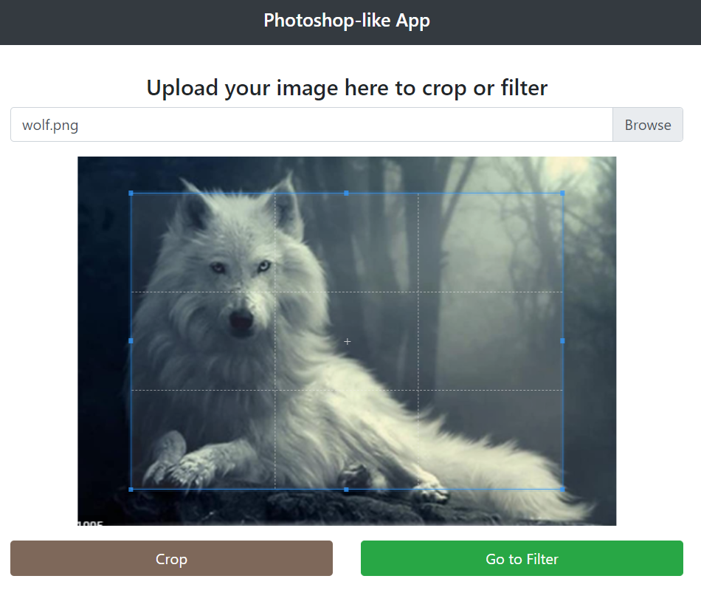

## Step 2: Crop the image

*The second step is cropping the image uploaded.

*Users just need to resize the cropping area with a light-blue border provided and click on the “Crop” button below the image to crop the image.

*In the example below, the head of the wolf was cropped.

**The diagram below shows the image before being cropped:**

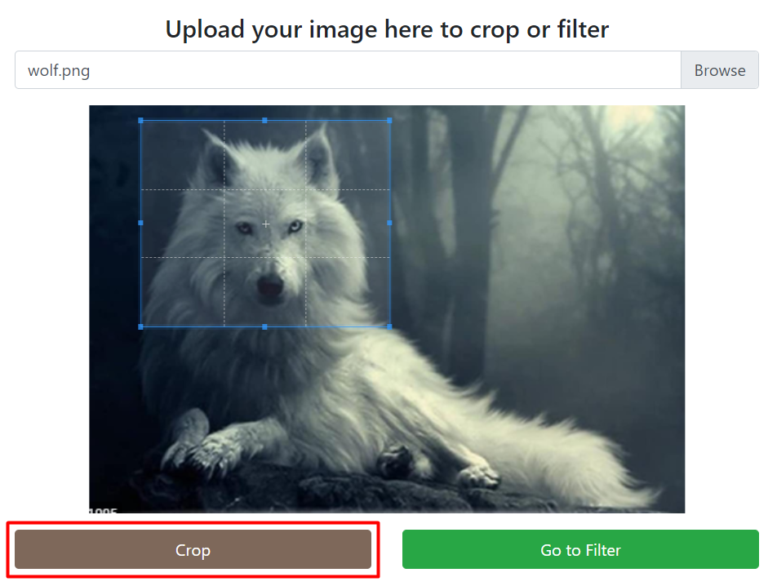

**The diagram below shows the image after being cropped:**

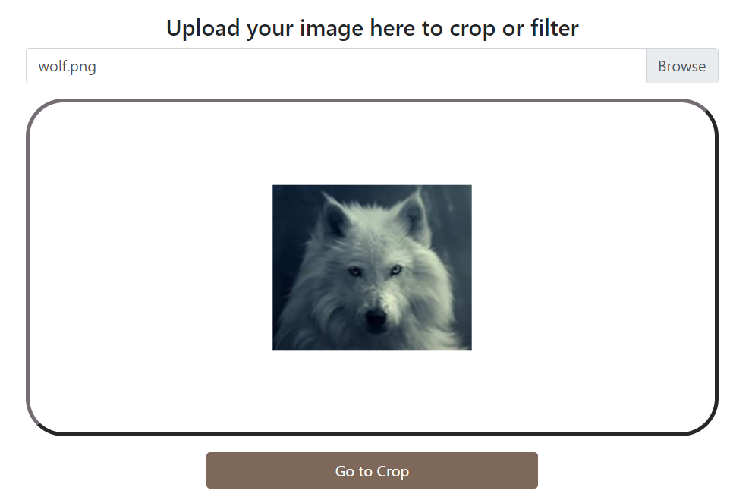

## Step 3: Rotate the image

*The third step is rotating the image if the users wish to.

*Users just have to click on the “Rotate” button to rotate the image by 90o in a clockwise direction.

*In the example below, the image was rotated 270 o in a clockwise direction by clicking on the “Rotate” button for three times.

**The diagram below shows the image before being rotated for 270o :**

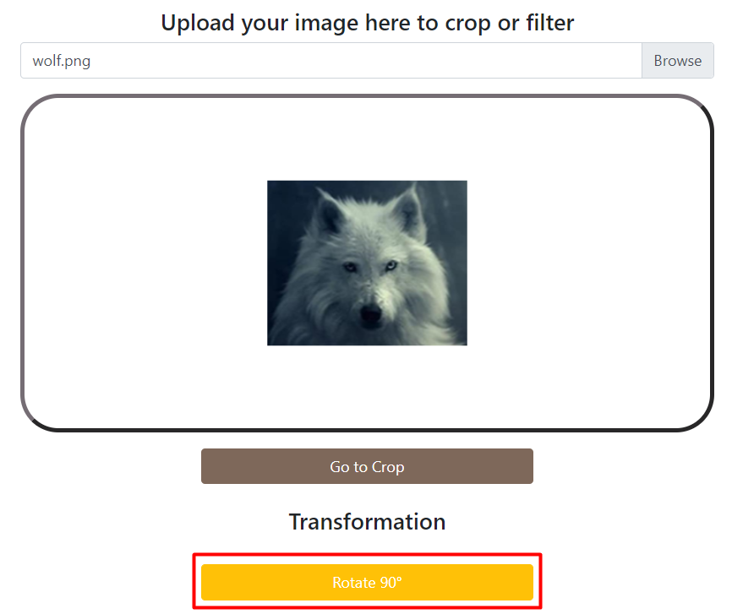

**The diagram below shows the image after rotated for 270o :**

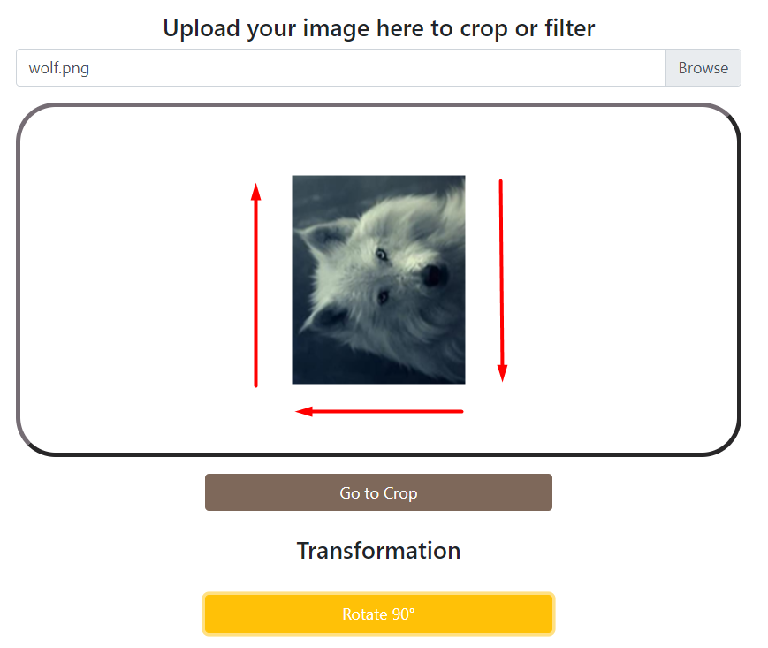

270o

90o

180o

## Step 4: Apply filters

*The fourth step is applying filters on the image.

*In the example below, brightness was adjusted or increased by clicking on the “+” symbol in the button group named “Brightness”.

**The diagram below shows the image before being applied the filter (Brightness) :**

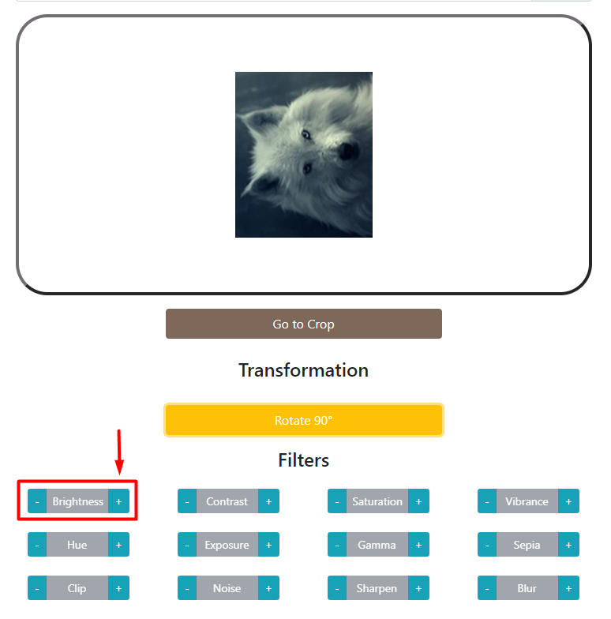

**The diagram below shows the image after being applied the filter (Brightness) :**

*The image looks brighter when compared to the image before being filtered.

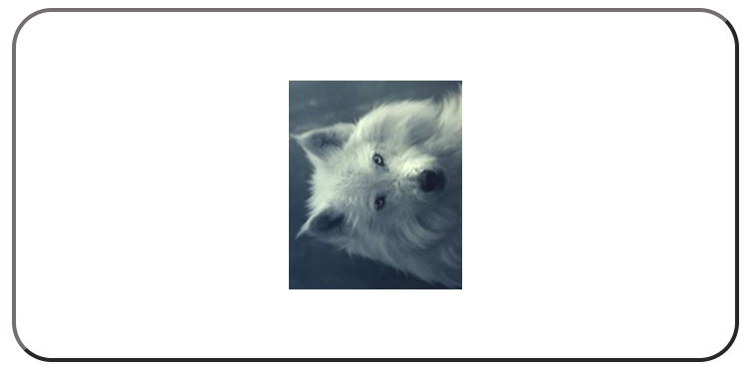

## Step 5: Add special effects

*The fifth is adding special effects on the image.

*Users just need to click on the “Special Effects” button such as “Vintage” and “Lomo” to add special effects on the image.

*In the example below, the special effect named “Vintage” was added to the image.

**The diagram below shows the image before being added the special effect (Vintage) :**

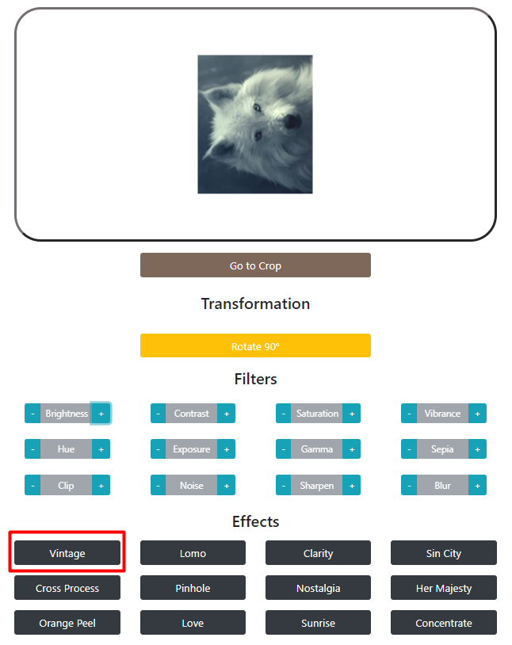

**The diagram below shows the image after being added the special effect (Vintage) :**

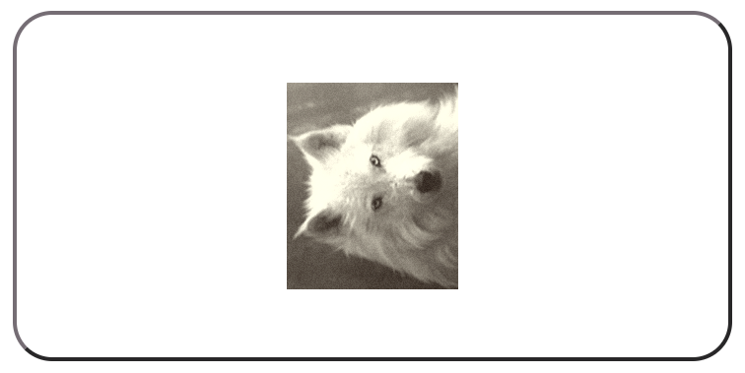

## Step 6: Add a watermark

*The sixth step is adding a watermark on the image for the sake of preventing the edited images from being misused by others.

*Users just have to enter the watermark content in the text box given and click on the “Add Watermark” button to add a watermark on the image.

*In the example below, a watermark with the content of “Wolf” was added to the image.

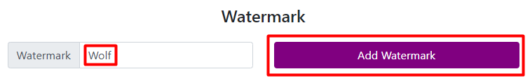

**The diagram below shows the image after being added the watermark :**

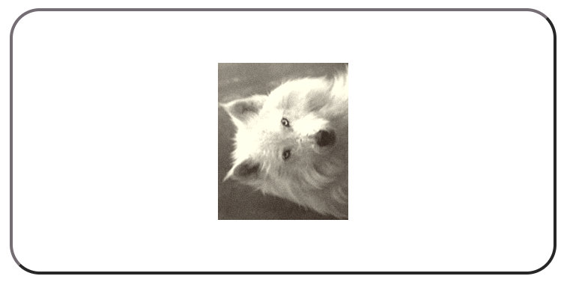

**The diagram below shows the image after being added the watermark :**

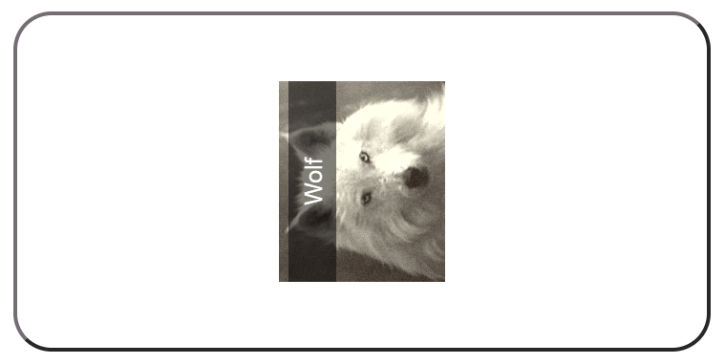

## Step 7: Download the image

*The seven and last step is downloading the image if users have already satisfied the final edited image.

*Users just need to click on the “Download Image” button at the left bottom of the page to download the edited image into their local computers.

*In the example below, the edited image was saved with name of “wold-edited.png”.

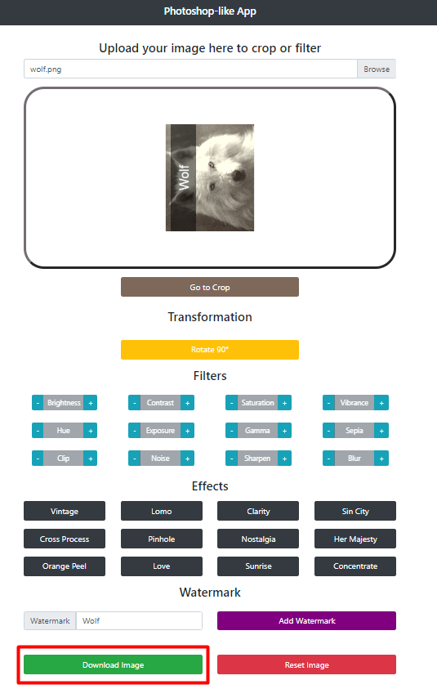

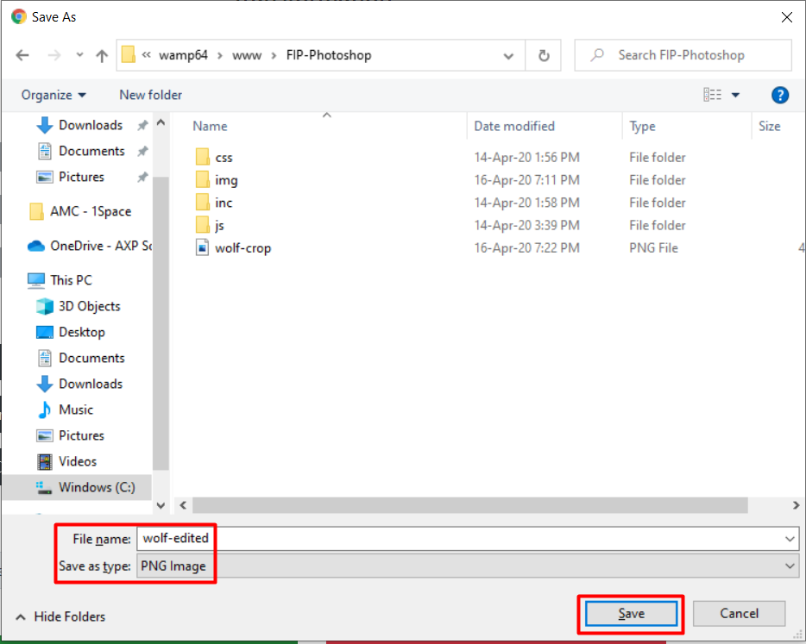**The diagram below shows the downloaded image :**

**The diagram below shows the downloaded image opened in an image viewer:**

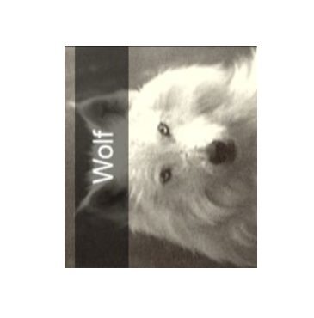

## Extra Step: Reset to the original image

*If users find that the image edited looks weird and they want to edit from the first step again, they can click on the “Reset Image” button to remove filters, special effects and other edits applied to the image.

*In the example below, the image was reset back to the original image.

**The diagram below shows the image before being reset :**

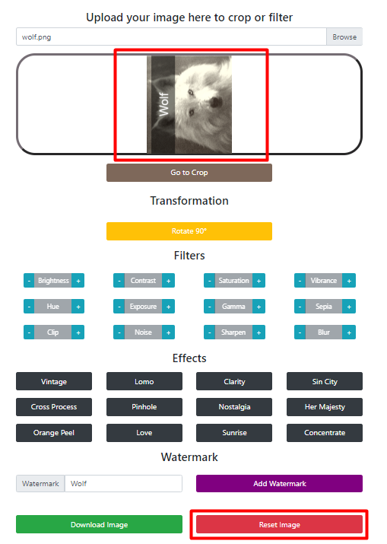

**The diagram below shows the image after being reset :**

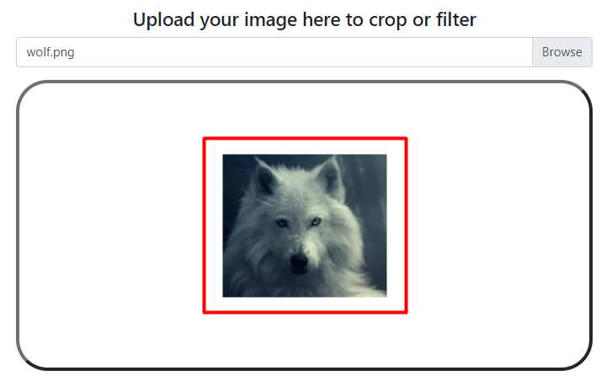

# Out of Scope

The drawback of our application is that this application is not able to handle the scaling part. In other words, this application is not able to process the image uploaded with the original file size larger than the editing area or canvas.

# Programming Languages Used

1. HTML
2. CSS
3. Java Script
4. jQuery
5. PHP